

A
Project Report
on
Secure E-Tender Allocation Using Blockchain
submitted as partial fulfillment for the award of
BACHELOR OF TECHNOLOGY
DEGREE
SESSION 2022-23
in
Computer Science and Engineering
By
Vipul Kumar (1900290100195)
Vishwaas Saxena (1900290100196)
Shivangi Pandey (1900290100145)

Under the supervision of
Prof. Neha Yadav
KIET Group of Institutions, Ghaziabad
Affiliated to
Dr. A.P.J. Abdul Kalam Technical University, Lucknow
(Formerly UPTU)
May, 2023

DECLARATION
We hereby declare that this submission is our own work and that, to the best of our knowledge and belief, it contains no material previously published or written by another person nor material which to a substantial extent has been accepted for the award of any other degree or diploma of the university or other institute of higher learning, except where due acknowledgment has been made in the text.
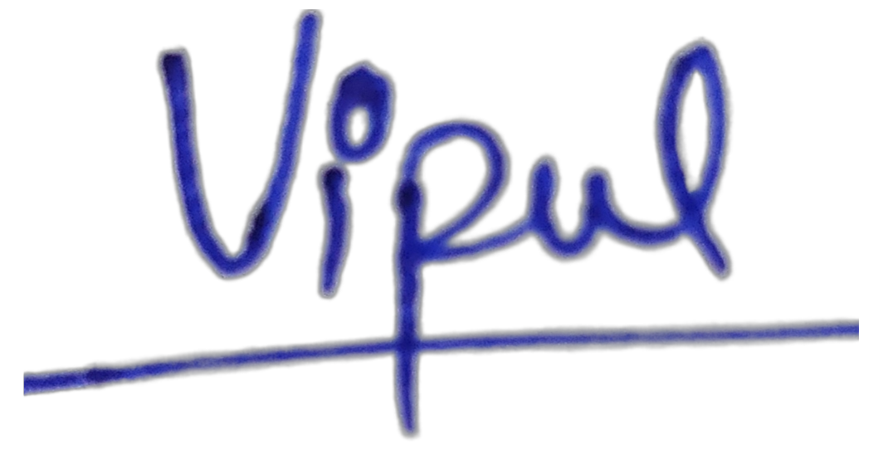

Signature
Name: Vipul Kumar
Roll No.: 1900290100195
Date: 27/05/2023


Signature
Name: Vishwaas Saxena
Roll No.: 1900290100196


Signature
Name: Shivangi Pandey
Roll No.: 1900290100145

CERTIFICATE

This is to certify that Project Report entitled “Secure E-Tender Allocation Using Blockchain” which is submitted by Vipul Kumar in partial fulfillment of the requirement for the award of degree B. Tech. in Department of Computer Science & Engineering of Dr. A.P.J. Abdul Kalam Technical University, Lucknow is a record of the candidates own work carried out by them under my supervision. The matter embodied in this report is original and has not been submitted for the award of any other degree.



Date: 27/05/2023 Neha Yadav
(Assistant Professor)

ACKNOWLEDGEMENT

It gives us a great sense of pleasure to present the report of the B. Tech Project undertaken during B. Tech. Final Year. We owe special debt of gratitude to Prof. Neha Yadav, Department of Computer Science & Engineering, KIET, Ghaziabad, for her constant support and guidance throughout the course of our work. Her sincerity, thoroughness and perseverance have been a constant source of inspiration for us. It is only her cognizant efforts that our endeavors have seen light of the day.
We also take the opportunity to acknowledge the contribution of Dr. Vineet Sharma, Head of the Department of Computer Science & Engineering, KIET, Ghaziabad, for his full support and assistance during the development of the project. We also do not like to miss the opportunity to acknowledge the contribution of all the faculty members of the department for their kind assistance and cooperation during the development of our project.
We also do not like to miss the opportunity to acknowledge the contribution of all faculty members, especially faculty/industry person/any person, of the department for their kind assistance and cooperation during the development of our project. Last but not the least, we acknowledge our friends for their contribution in the completion of the project.
Date: 27/05/2023

Signature
Name : Vipul Kumar
Roll No.: 1900290100195

Signature
Name: Vishwaas Saxena
Roll No.: 1900290100196

Signature
Name: Shivangi Pandey
Roll No.: 1900290100145
ABSTRACT

This paper presents a detailed proposal for a blockchain-based tender allocation project that aims to address the problems associated with existing tender allocation systems. The traditional systems suffer from a lack of transparency, high risk of fraud, inefficiency, lack of trust, and limited access. The proposed blockchain-based solution aims to create a decentralised, secure, and transparent platform for the allocation of tenders, enabling trustless and anonymous interactions, and providing an open, accessible platform for all participants.

The project will be developed using smart contracts, a key feature of blockchain technology that allows for automated, secure, and transparent execution of contracts. These smart contracts will be used to create a tamper-proof, auditable, and decentralised tender allocation platform that will allow for seamless bidding and allocation of tenders. The use of digital identities and other digital assets will ensure the authenticity of the participants and prevent fraud.

The proposed blockchain-based tender allocation platform offers a range of benefits compared to traditional tender allocation systems. Firstly, it will provide increased transparency, allowing all participants to view the entire tender allocation process. This will reduce suspicions of favouritism and corruption, leading to a more trustworthy and fair system. Secondly, the use of smart contracts will enable automated and secure execution of contracts, reducing the risk of fraud and other malicious activities. Thirdly, the system will be more efficient, reducing the time and costs associated with the tender allocation process.

The project will create a level playing field for all participants, including small and medium-sized businesses, enabling them to compete with larger organisations for tenders. By removing the need for intermediaries and providing an open, accessible platform, the proposed solution will democratise the tender allocation process.
There are, however, some challenges to implementing a blockchain-based tender allocation system. These include scalability, interoperability, and regulatory compliance. The paper discusses these challenges in detail and proposes solutions to overcome them.
Overall, this paper demonstrates the potential of blockchain technology to revolutionise the way we conduct business and manage transactions, particularly in the area of tender allocation. The proposed blockchain-based tender allocation project offers a range of benefits, including increased transparency, improved efficiency, and greater trust between participants. It provides a scalable, interoperable, and regulatory compliant solution that is accessible to all, enabling fair and equal opportunities to secure contracts.

TABLE OF CONTENTS | Page No.
DECLARATION………………………………………………………………….…. | ii
CERTIFICATE…………………………………………………………………….… | iii
ACKNOWLEDGEMENTS………………………………………………………….. | iv
ABSTRACT………………………………………………………………………..... | v
LIST OF FIGURES………………………………………………………………….. | ix
LIST OF TABLES…………………………………………………………………… | x
CHAPTER 1 (INTRODUCTION)……………………………………………..……. | 1
1.1. Introduction……………………………………………………………………... | 1
1.2. Problem Statement………………………………………………………………. | 4
1.3. Related Work……………………………………………………………………. | 9
1.4. Project Description……………………………………………………………… | 10
CHAPTER 2 (LITERATURE RIVIEW) ……...…………………………..…..……. | 12
2.1. Theoretical Framework……………………………………………………..…… | 12
2.2. Conceptual Framework………………………………………………….………. | 15
2.3 Empirical Studies………………………………………………………….……... | 16
CHAPTER 3 (PROPOSED METHODOLOGY) ….................................................... | 17
3.1. Design…………………………………………………………………………… | 17
3.2. Implementation………………………………………………………………….. | 18
CHAPTER 4 (RESULTS AND DISCUSSION) ......................................................... | 20
4.1. Overview of the study findings…………………………………………………. | 20
4.2. Detailed Results and Interpretations………………………………………….…. | 21
4.3. Comparison with previous studies………………………………………….…… | 22
4.4. Gas Usage Analysis……………………………………………………….…….. | 27
CHAPTER 5 (CONCLUSIONS AND FUTURE SCOPE) ......................................... | 28
5.1. Conclusion……………………………………………………………………… | 28
5.2. Limitations of the Study of Blockchain………………………………………… | 30
5.3. Future Scope……………………………………………………………………. | 33
REFERENCES………………………………………………………………………. | 34
APPENDIX 1………………………………………………………………………... | 36

LIST OF FIGURES

Figure No. | Description | Page No.
1 | Create Tender | 10
2 | Create Tender Output | 10
3 | Place Bid Dialogue Box | 11
4 | No permission to create tender | 11
5 | Interface to allow only specific companies to bid | 23
6 | Already Placed bid error | 24
7 | Error shown if the user tries to bid after the tender deadline | 24
8 | Details of the active tenders | 25
9 | Details of closed tenders along with the winner | 25
10 | Interface show bid details of all the participants | 26
11 | Winner not appointed error message | 26
12 | Gas Usage bar graph | 27

LIST OF TABLES

Table. No. | Description | Page No.
1 | Literature Review | 13

CHAPTER 1
INTRODUCTION

1.1 Introduction
Nearly all industries and regions of the world have seen a significant increase in the use of blockchain technology. In order to improve the level of security, privacy, transparency, and efficiency of work, government tender processes can make use of very promising blockchain technology. Blockchain technology can make it possible for all parties interested in each offer to be a part of the same network and to track the workflow in real-time. Governments in countries like Georgia, the UK, the UAE, Australia, China, Japan, and Russia are integrating blockchain technology into their daily operations at a rapid rate right nowadays. In recent years, the governments of several developing nations, including India, are coming up with initiatives and regulations for the adoption of blockchain technology.

In all industries and regions of the world, the usage of blockchain technology has grown quickly. To increase the level of security, privacy, openness, and productivity throughout the government tender process, blockchain technology is a very promising alternative. Blockchain technology can enable all parties engaged in each tender to be a member of the same network and track the workflow in real time.

Blockchain technology has the potential to revolutionize the way we conduct business and manage transactions. One area where this technology can be particularly useful is in the allocation of tenders. A blockchain-based tender allocation project aims to use the decentralised and secure nature of blockchain technology to create a transparent and efficient system for the distribution of government contracts and other tenders. This can help to reduce the risk of fraud, increase transparency, and improve the overall efficiency of the tender allocation process. The project would involve the use of smart contracts and other blockchain-based solutions to create a decentralised platform for tender allocation. It would also involve the use of digital identities and other digital assets to ensure the authenticity of the participants involved in the process. Overall, the goal of a blockchain-based tender allocation project is to create a more efficient and transparent system for the distribution of government contracts and other tenders, while also reducing the risk of fraud and other malicious activities

In other terms, blockchain is a digital ledger for transactions or contracts that need to be recorded. It is a secure, distributed database that stores data. In all industries and regions of the world, the usage of blockchain technology has increased more quickly.

Blockchain is a digital ledger for transactions or contracts that need to be recorded. It is a secure, distributed database that stores data. In all industries and regions of the world, the usage of blockchain technology has increased more quickly. There has been a rapid growth in the use of blockchain technology in almost all domains and all parts of the world. Blockchain technology is a highly promising solution that can
be employed in the government tender process to enhance the level of security, privacy, transparency, and speed of work. Blockchain can allow all the parties involved in a particular tender to be a part of the same network and to monitor the work-ﬂow step by step. Governments like Georgia, UK, UAE, Australia, China, Japan, and Russia are currently
progressing at a rapid pace in adapting blockchain in their day-to-day functioning.

There have been various attempts to implement the technology to make government processes paperless and instantaneous, such as online ticketing systems, online issuing of tenders, filing tax returns, etc. Although most of these systems seem robust and well implemented, all of them are based on the idea of a central server that has a single point of failure, as hackers can easily hack or disrupt its functioning by attacks, such as DOS, Slow-loris, SYN Flooding, etc. In most governments, complicated bureaucratic systems often result in highly inefficient workflow fraught with corruption, mismanagement, and human errors. Some of the governance processes, such as government tenders include malpractices like information leaks, corruption, bribery, etc. Most of the existing electronic services and IT infrastructure have the above-mentioned limitations, however, new technologies, such as blockchain have the potential to greatly ameliorate the existing problems. A permissioned blockchain network can provide the necessary transparency to effectively implement government policies for the benefit of the citizens of the country and fix responsibilities in case of abuse of the system.

In the current digital space, data manipulation is one of the most important tools that is being used by all the adversaries and malicious entities to cause harm to the public and the government bodies. Most of the existing systems rely on the data and if the data itself is far from correlated or misreported, then the complete system becomes corrupt. The shift from storing data in physical ﬁles to storing data in digital form is a paradigm shift. However, if the digital data is not secure, then the harm caused by the loss of digital data would be much more than the harm that was faced due to the loss of physical ﬁles. According to 2019 statistics, there are more than 130 large-scale targeted data breaches in the U.S. per year, and that number is growing by around 27 percent per year. Digital Identity theft is one of the major sources of data breaches. It is estimated that 74% of the data breaches are caused by identity thefts across the world. The United States leads other countries with almost 85 percent of digital identities stolen worldwide.

Identity management is one of the major areas that has gained a lot of focus in recent years. Authors have proposed various blockchain-based methods and frameworks to generate a secure, single, and immutable identity for all citizens. Various secure E-voting possibilities to make the process of voting secure and easy are proposed in. The decentralized nature of blockchain can mitigate the risk of a single centralized authority getting malicious and creating a risk to the voting system. Different authors of proposed a model that facilitates government information management and sharing based on the blockchain network. Although there have been a few recent attempts to create a decentralized application for the government tender process, the overall interest of the government and constructors is not considered. The proposed framework gives a major focus on enhancing the ultimate experience of the constructors and government ofﬁcials. The target of the proposed model is to create an end-to-end edge computing framework where all entities can be the part of same network and the ofﬁcial works can ﬂow in a completely transparent and non-biased manner.

Although there have been a few recent attempts to create a decentralized application for the government tender process, the overall interest of the government and constructors is not considered. The proposed framework gives a major focus on enhancing the ultimate experience of the constructors and government ofﬁcials. The target of the proposed model is to create an end-to-end edge computing framework where all entities can be the part of the same network and the ofﬁcial works can ﬂow in a completely transparent and non-biased manner.

1.2 Problem Statement
Traditional tender allocation systems have been in use for many years but they are not without their limitations. One of the primary drawbacks of these systems is that they are often reliant on intermediaries, such as banks or third-party auditors.
This dependence on intermediaries can lead to issues such as delays, high transaction fees, and the potential for fraud or corruption. Additionally, traditional tender allocation systems are often manual, paper-based processes that can be time-consuming, error-prone, and inefficient.
Approach to the problem
Smart Contract Design
Smart Contracts are legally enforceable agreements, create operational parameters connected to a standard form of code. A smart contract is put in place to ensure that the transaction will not get added to the block until all nodes successfully verify and mark the transaction as complete.
Decentralized Document Storage
Since most of the transactions usually involve various types of documents that need to be processed, a 3-layer file encryption model is created that allows hassle-free and secure decentralized storage for all the required documents in a particular transaction.
Consensus Algorithm
We consider a network model involving multiple constructors, lenders, and tenders. Lenders propose the tender they are interested in and provide the expected time period, cost, and the period of maintenance required after the tender completion. Constructors bid on the tender and give the time period, cost, and maintenance period they can provide for the tender. Consensus is a way of reaching an agreement between the nodes.

Optimal Price Formulation
The lenders get the best resources at the lowest prices, and the constructors get the best tenders matching the resources they have. These formulations are not specific to a constructor, government lender, or tender.
- We have developed a tkinter based interface with the help of which the contractors and the bidder can communicate with the contracts.
- First, the users need to sign in as a contractor or bidders. The contractor will have the option to create a tender and upload it on the blockchain network. The contract uploaded will be available to all the bidders present on the network for which the bidders can decide whether to bid or not.
- Bidders are allowed to bid only once and that is to be within the time duration of the contract. Each and every bid will have a score which will be calculated using Score Formulation Parameters. After the deadline of the contract is over the bidder with the minimum score will be selected as the winner of the contract.
- The details of the participants and the winner of the tender will also be available only after the winner is declared.

Decentralisation in Blockchain
One of the most important concepts in blockchain technology is decentralisation. No one computer or organisation can own the chain. Instead, it is a distributed ledger via the nodes connected to the chain. Blockchain nodes can be any kind of electronic device that maintains copies of the chain and keeps the network functioning.
Every node has its copy of the blockchain and the network must algorithmically approve any newly mined block for the chain to be updated, trusted, and verified. Since blockchains are transparent, every action in the ledger can be easily checked and viewed, creating inherent blockchain security. Each participant is given a unique alphanumeric identification number that shows their transactions.
Combining public information with a system of checks and balances helps the blockchain maintain the integrity and creates trust among users. Essentially, blockchains can be thought of as the scalability of trust via technology.

Cryptocurrency: Blockchain vs Cryptocurrency
Blockchain’s most well-known use (and maybe most controversial) is in cryptocurrencies. Cryptocurrencies are digital currencies (or tokens), like Bitcoin, Ethereum or Litecoin, that can be used to buy goods and services. Just like a digital form of cash, crypto can be used to buy everything from your lunch to your next home. Unlike cash, crypto uses blockchain to act as both a public ledger and an enhanced cryptographic security system, so online transactions are always recorded and secured.
The term Bitcoin, for example, is used interchangeably to refer to both the blockchain and the cryptocurrency, but they remain as two separate entities. The very first blockchain application appeared in 2009 as Bitcoin, a cryptosystem using the distributed ledger technology. This also marked Bitcoin as the first “blockchain.” The aspect of blockchain being used to house this new digital currency is what brought both entities into association, and what led them quickly into the spotlight. The Bitcoin blockchain describes only the technology in which the currency is housed, while the Bitcoin cryptocurrency describes only the currency itself.
To date, there are more than 20,000 cryptocurrencies in the world that have a total market cap of around $1 trillion, with Bitcoin holding a majority of the value. These tokens have become incredibly popular over the last few years, with the value of one Bitcoin fluctuating between several thousands of dollars.
Here are some of the main reasons behind cryptocurrency’s recent popularity:
- Blockchain’s security makes theft much harder since each cryptocurrency has its own irrefutable identifiable number that is attached to one owner.
- Crypto reduces the need for individualised currencies and central banks. With blockchain, crypto can be sent anywhere and anyone in the world without the need for currency exchange or without interference from central banks.
- Cryptocurrencies can make some people rich. Speculators have been driving up the price of crypto, especially Bitcoin, helping some early adopters to become billionaires. Whether this is a positive has yet to be seen, as some retractors believe that speculators do not have the long-term benefits of crypto in mind.
- More and more large corporations came around to the idea of a blockchain-based digital currency for payments. In February 2021, Tesla announced that it would invest $1.5 billion into Bitcoin and accept it as payment for its cars.
Of course, there are many legitimate arguments against blockchain-based digital currencies. First, crypto isn’t a very regulated market. Many governments were quick to jump crypto, but few have a staunch set of codified laws regarding it. Additionally, crypto is incredibly volatile due to speculators. Lack of stability has caused some people to get very rich, while most still lost thousands of dollars.
Whether or not digital currencies are the future remains to be seen. For now, it seems as if blockchain’s meteoric rise is more starting to take root in reality than pure hype. Though it’s still making headway in this entirely-new, highly-exploratory field, blockchain is also showing promise beyond Bitcoin.

Blockchain Platform
While a blockchain network describes the distributed ledger infrastructure, a blockchain platform describes a medium where users can interact with a blockchain and its network. Blockchain platforms are created to be scalable and act as extensions of an existing blockchain infrastructure, allowing information exchange and services to be powered directly from this framework.
An example of a blockchain platform includes Ethereum, a software platform that houses the Ethereum, or ether, cryptocurrency. With the Ethereum platform, users can also create programmable tokens and smart contracts built directly upon the Ethereum blockchain infrastructure.

Beyond Bitcoin: Ethereum Blockchain
Originally created for Bitcoin to operate on, blockchain has long been associated with cryptocurrency, but the technology's transparency and security has seen growing adoption in a number of areas, much of which can be traced back to the development of the Ethereum blockchain.
In late 2013, Russian-Canadian developer Vitalik Buterin published a white paper that proposed a platform combining traditional blockchain functionality with one key difference: the execution of computer code. Thus, the Ethereum Project was born.
Today, the Ethereum blockchain lets developers create sophisticated programs that can communicate with one another through the blockchain itself.
Similarly to Bitcoin, it’s worth noting that the Ethereum blockchain and the Ethereum cryptocurrency are two separate entities.

Tokens
Ethereum programmers can create tokens to represent any kind of digital asset, track its ownership, and execute its functionality according to a set of programming instructions.
Tokens can be music files, contracts, concert tickets, or even a patient’s medical records. In the past couple of years, non-fungible tokens (NFTs) have grown in popularity. NFTs are unique blockchain-based tokens that store digital media (like a video, music, or art). Each NFT has the ability to verify authenticity, past history, and sole ownership of the piece of digital media. NFTs have become wildly popular because they offer a new wave of digital creators the ability to buy and sell their creations while getting proper credit and a fair share of profits.
Newfound uses for blockchain have broadened the potential of the ledger technology to permeate other sectors like media, government, and identity security. Thousands of companies are currently researching and developing products and ecosystems that run entirely on burgeoning technology.
Blockchain is challenging the current status quo of innovation by letting companies experiment with groundbreaking technology like peer-to-peer energy distribution or decentralized forms for news media. Much like the definition of blockchain, the uses for the ledger system will only evolve as technology evolves.

Smart Contracts
What is a smart contract? These are digital, programmed contracts that automatically enact or document relevant events when specific terms of the agreement are met. Each contract is directly controlled through lines of code stored across a blockchain network. So once a contract is executed, agreement transactions become trackable and unchangeable. Though fundamental to the Ethereum platform, smart contracts can also be created and used on blockchain platforms like Bitcoin, Cardano, EOS.IO, and Tezos.

1.3 Related Work
There have been a number of recent studies and projects that have explored the use of blockchain technology in the context of tender allocation.
One notable project is the "Smart Tenders" platform developed by the European Union's Horizon 2020 research program. This platform uses blockchain technology to automate the evaluation of bids and the award of contracts. The platform also includes a reputation management system that allows bidders to build up a reputation over time, which can be used to evaluate the quality of their bids.
Another project is the "Blockchain-based Public Procurement Platform" developed by the government of the Republic of Korea. This platform aims to increase transparency and reduce the risk of fraud in the public procurement process. The platform uses blockchain technology to record all procurement activities and allows all participants to access the same information.

The "Blockchain-based e-Procurement System" developed by the government of Andhra Pradesh, India is also a noteworthy one. The system aims to digitise the procurement process and to use blockchain technology to ensure the transparency and security of the process. The system also allows for the tracking of goods and services through the supply chain.

In addition to these specific projects, there have also been a number of academic studies that have looked at the use of blockchain in tender allocation. For example, a study published in the Journal of Information Processing Systems found that blockchain technology could be used to improve the transparency and security of the tender allocation process. Another study published in the Journal of Business Research suggests that blockchain technology could be used to automate the evaluation of bids and the award of contracts, and that this could lead to significant improvements in the efficiency and fairness of the process.

Overall, related work on blockchain-based tender allocation projects has shown that the technology has the potential to bring transparency, immutability, and security to the tendering process. The use of smart contracts can automate the process and reduce human errors and bias. Blockchain-based systems can track the movement of goods and services through the supply chain. However, more research is required to understand the scalability and practicality of these solutions.

1.4 Project Description
When the government comes up with a new project, they pass a tender which is a type of proposal for contractors and builders to come up with their plans and ideas including the amount of time and budget that they will need to complete that project. Here, we initialised a blockchain based decentralised system to allocate those tenders to the most efficient contractor without any type of cheating with other contractors.

System has 3 types of users:
- Administrator: The government users which are responsible for creating the tenders, adding them to the portal and also judging the bids that have been made according to the predefined parameters.

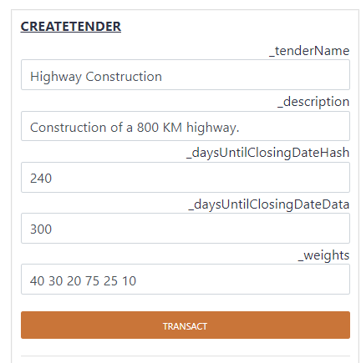
Fig 1. Create Tender
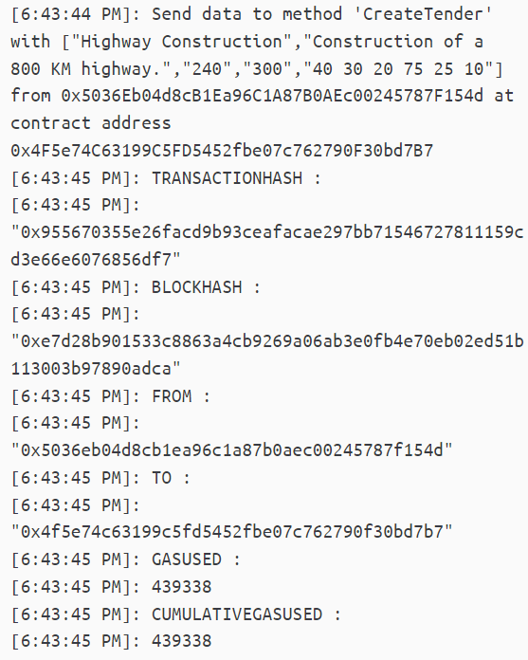
Fig 2. Create Tender Output

Bidders: The contractors/builders who are interested in the project will bid for the tender and provide details about the time required and the budget required.

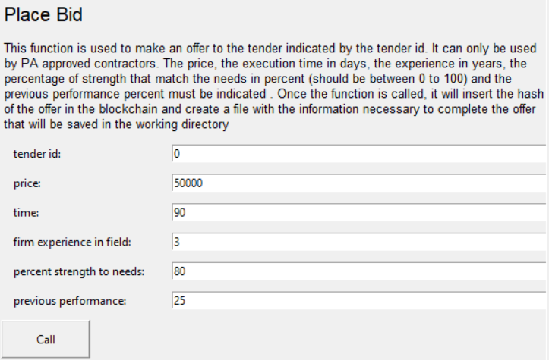
Fig 3. Place Bid Dialogue Box

Observers: The last category of users are those not bidding, who want information about upcoming tenders and results.

Also, tender has some parameters like time, price and environment. These parameters are the set of characteristics or requirements specified for a tender, a formal invitation to submit a proposal for a project or supply of goods or services.

If any non-administration user tries to create a new tender, then a pop-up error comes and notifies the user.

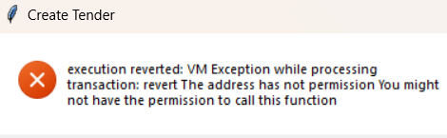
Fig 4. No permission to create tender

CHAPTER 2
LITERATURE REVIEW

2.1 Theoretical Framework
The theoretical framework of a blockchain-based secure tender allocation system includes the
following concepts:

Blockchain Technology: The underlying technology behind the secure tender allocation system is blockchain, which is a decentralised, distributed ledger that records transactions in a secure and transparent manner.

Smart Contracts: Smart contracts are self-executing computer programs that are stored on the blockchain and automatically execute when certain conditions are met. In a secure tender allocation system, smart contracts can be used to enforce the terms and conditions of a tender and ensure that all parties comply with them.

Distributed Consensus: Blockchain networks rely on a distributed consensus mechanism to validate transactions and prevent fraud. In a secure tender allocation system, the distributed consensus mechanism ensures that all bids are valid and that the winning bid is determined fairly.

Cryptography: Cryptography is used in blockchain networks to secure data and prevent unauthorised access. In a secure tender allocation system, cryptography can be used to secure the tender documents and ensure that only authorised parties have access to them.
Trustless System: A blockchain-based secure tender allocation system is a trustless system, which means that parties do not need to trust each other to conduct transactions. The blockchain provides a secure and transparent environment that eliminates the need for intermediaries and reduces the risk of fraud.
Transparency: Transparency is a key feature of blockchain networks, which allows all parties to see and verify transactions. In a secure tender allocation system, transparency ensures that all bids are visible to all parties and that the winning bid is determined fairly.
By using these theoretical concepts, a blockchain-based secure tender allocation system can provide a secure, transparent, and fair environment for conducting tenders.

Blockchain Technology | Merits | Demerits
Edge computing and decentralised  consortium | double auctioning and less chance of data piracy due to edge computing | 1.Overall interest of  the government and  constructors not  considered.  2.Requires massive  computing power to  achieve consensus  and the transaction  history is visible to  everyone.
Blockchain and  smart contract | transparent and secure | data piracy
Blockchain-based  e-Tendering  System | 1. Once the tender is complete any bidder can get the winner details consisting of quotation amount and clauses of the winning bid. The bidders can compare this  information with their bids to  evaluate where they lacked  and what had gone wrong.  2. All the bids that were created and negotiated are also released to the participating organizations. Hence, making the process of bidding and winner selection highly transparent and secure. | The Smart Contract  can be made more  secure by using more complex cryptographic  algorithms.
Implementing  decentralized  auctions using  blockchain smart  contracts | 1. Implemented an English reverse  auction using an Ethereum  smart contract in which the leading  bid was known throughout  the bidding process.  2.The proposed solution in this  research paper is generic  enough and can be applied  to other auctioning types too like  English Forward auction , dutch  auction ,etc. | maintained a modular  way of entering the  file hashes.  Therefore, this  modular design can  cost more on-chain.
Fair and  transparent  Blockchain  System | 1. Allows users to monitor working for a government body.  2.Reduce the risk of fraud and corruption. | 1. Require efficient  tools and intuitive  Assessment.  2. Every operation  require Gas payment.
Table 1: Literature Review Table

2.2 Conceptual Framework
The conceptual framework of a blockchain-based secure tender allocation system includes the following concepts:

Tender Creation: The tender creation process involves the creation of a smart contract on the blockchain that defines the terms and conditions of the tender. The smart contract includes details such as the tender deadline, the tender documents, the evaluation criteria, and the eligibility criteria.
Bid Submission: Bidders can submit their bids through the blockchain-based secure tender allocation system, which ensures that only authorized bidders can access the tender documents and submit their bids. The bids are stored on the blockchain and are visible to all parties.
Bid Evaluation: The bid evaluation process is automated and is based on the evaluation criteria defined in the smart contract. The smart contract automatically evaluates the bids and determines the winning bid.
Winner Declaration: Once the winning bid has been determined, the blockchain-based secure tender allocation system declares the winner and stores the result on the blockchain. The winner can then proceed with the contract execution process.
Security and Transparency: The blockchain-based secure tender allocation system provides a secure and transparent environment for conducting tenders. The use of cryptography and distributed consensus ensures that the system is secure, while the transparency of the blockchain ensures that all parties can see and verify transactions.
Trustless System: The blockchain-based secure tender allocation system is a trustless system, which means that parties do not need to trust each other to conduct transactions. The blockchain provides a secure and transparent environment that eliminates the need for intermediaries and reduces the risk of fraud.

By using these conceptual concepts, a blockchain-based secure tender allocation system can provide a secure, transparent, and trustless environment for conducting tenders. The system ensures that all parties can participate in tenders on a level playing field, and that the winning bid is determined fairly and transparently.

2.3 Empirical studies
Empirical Studies in blockchain-based secure tender allocation systems can be conducted to evaluate the effectiveness and efficiency of the system in real-world scenarios. These studies involve collecting data from actual users and analysing the results to draw conclusions about the system's performance.
Some common empirical studies that can be conducted in a blockchain-based secure tender allocation system include:

User satisfaction surveys: These surveys can be conducted to gather feedback from users about their experience with the system. Questions can be asked about ease of use, efficiency, and overall satisfaction.

Time and cost analysis: These studies can be conducted to compare the time and cost required to allocate tenders using the blockchain-based system with traditional methods. This analysis can help determine whether the blockchain-based system provides a cost-effective and time-efficient alternative to traditional tender allocation methods.

Performance analysis: These studies can be conducted to evaluate the performance of the system under different conditions, such as varying numbers of tenders and bidders. This analysis can help determine the scalability and reliability of the system.

Empirical studies can provide valuable insights into the performance of a blockchain-based secure tender allocation system and can help identify areas for improvement. The results of these studies can also be used to demonstrate the effectiveness of the system to potential users and stakeholders.

CHAPTER 3
PROPOSED METHODOLOGY
3.1 Design
Designing a blockchain-based e-tendering system involves several key components and considerations. Here is a high-level design outline for such a system:

Blockchain Infrastructure:
- Determine the type of blockchain: Decide whether to use a public or private blockchain based on the specific requirements and participants involved.
- Consensus mechanism: Select an appropriate consensus algorithm to ensure agreement on the validity of transactions.
- Network structure: Establish the network topology, such as a peer-to-peer network, to enable decentralised data storage and validation.
- Blockchain platform: Choose a suitable blockchain platform that supports smart contracts and provides necessary tools and libraries.

Smart Contract Development:
- Define smart contract functionality: Identify the specific functionalities required for the e-tendering system, such as bid submission, evaluation, contract execution, and payment.
- Develop smart contracts: Implement the identified functionalities using a programming language suitable for the selected blockchain platform.
- Consider contract upgradability: Design the smart contracts to allow for upgradability, enabling the system to adapt to future changes and improvements.

Tender creation:
- Enable the creation of tender requests, including detailed specifications, submission deadlines, and evaluation criteria.
- Bid submission: Provide a user-friendly interface for participants to submit their bids securely and transparently.
- Bid evaluation: Implement an automated evaluation process that follows predefined criteria, ensuring fairness and transparency.
- Contract execution: Facilitate the execution of contracts based on the winning bid, including terms and conditions, payment milestones, and deliverables.

3.2 Implementation
The implementation of the projects is divided into 4 main sections:

Creating Tender: The administrator from the government side creates a new Tender and makes it visible for the contractors to bid on.

Placing Bid: Interested parties can bid according to their choice, providing their time duration and budgets, These bids are placed taking into consideration the various parameters that have been put forth for each other organisations that are placing the bids.

Bid Parameters: The Bid Parameters are the main calculus of the system, there are various bid parameters that are used in the system:
- Price: The price that the bidder is offering.
- Time: The time duration in which the bidder will meet the needs as given out by the organisation.
- Environment: The environment parameter is further divided into subcategories:
  - Experience: The work experience of the firm.
  - Percentage Match Between the need and the strength: This factor determines the degree to which the need and strength of the bidding organisation match.
- Deliverance Rate: This factor determines the success rate at which the organisation has delivered in the past.

These parameters are the set of characteristics or requirements that are specified for a tender, which is a formal invitation to submit a proposal for a project or supply of goods or services.

Score Formulation: All the parameters that have decided responsible for the formulating the score, all these parameters have weights associated to them, the weights are multiplied to the respective parameter and an average score is formulated using these weights along with parameters for each of the bidders and then the maximum score among all the bidders is finally calculated.
Winner Assign: The winner assignment is done as per the score formulation done using the parameters, the scores of all the bidders are compared and among them the highest score is assigned as the winner and the winner is declared accordingly.

CHAPTER 4
RESULTS AND DISCUSSION

4.1 Overview of the study findings
The findings of a study on a blockchain-based secure tender allocation system may include the following:
- The effectiveness of the system in providing secure and transparent tender allocation.
- The accuracy of the system in recording and tracking tender-related data.
- The level of acceptance and satisfaction of the stakeholders, including tender issuing authorities, bidders, and the public.
- The impact of the system on reducing corruption, minimising errors, and improving efficiency.
- The challenges and limitations of implementing the system, including technical issues, legal barriers, and resistance to change.
- The potential for further development and improvement of the system, such as integrating smart contract technology or using artificial intelligence to enhance decision-making.

Overall, the study findings of a blockchain-based secure tender allocation system can provide valuable insights into the benefits, challenges, and potential of using blockchain technology in public procurement processes.

4.2 Detailed Results and Interpretations
The detailed results and interpretations of a study on a blockchain-based secure tender allocation system includes the following:

Effectiveness of the system: The study may have evaluated the effectiveness of the system in providing secure and transparent tender allocation. This may include analysing the accuracy of the system in recording and tracking tender-related data, the level of trust and confidence of the stakeholders, and the overall impact of the system on reducing corruption, minimizing errors, and improving efficiency.

Stakeholder acceptance and satisfaction: The study may have assessed the level of acceptance and satisfaction of the stakeholders, including tender issuing authorities, bidders, and the public. This may include analyzing the ease of use of the system, the level of transparency and fairness of the tender allocation process, and the overall satisfaction of the stakeholders.

Challenges and limitations: The study may have identified the challenges and limitations of implementing the system, including technical issues, legal barriers, and resistance to change. This may include analyzing the level of complexity of the system, the costs of implementation and maintenance, and the potential legal and regulatory issues associated with using blockchain technology in public procurement processes.

Potential for further development and improvement: The study may have explored the potential for further development and improvement of the system. This may include analyzing the potential for integrating smart contract technology, using artificial intelligence to enhance decision-making, and exploring new applications of blockchain technology in public procurement.

Overall, the detailed results and interpretations of a study on a blockchain-based secure tender allocation system can provide valuable insights into the benefits, challenges, and potential of using blockchain technology in public procurement processes. These findings can inform the development and implementation of future blockchain-based systems and contribute to the ongoing discussion on the role of blockchain technology in public sector innovation.

4.3 Comparison with previous studies
A comparison with previous studies on blockchain-based secure tender allocation systems may involve:

Methodology: The comparison may involve analyzing the methodology used in previous studies, such as the data collection and analysis methods, and comparing them with the methodology used in the current study.

Findings: The comparison may involve comparing the findings of previous studies with the findings of the current study. This may include analyzing similarities and differences in the effectiveness, stakeholder acceptance, challenges, and potential for improvement of the systems.

Limitations: The comparison may involve analyzing the limitations of previous studies and comparing them with the limitations of the current study. This may include analyzing the sample size, the geographical scope, and the limitations of the blockchain technology used in the studies.

Recommendations: The comparison may involve analyzing the recommendations made in previous studies and comparing them with the recommendations made in the current study. This may include analyzing the potential for further development and improvement of the systems, such as integrating smart contract technology or using artificial intelligence to enhance decision-making.

Overall, a comparison with previous studies on blockchain-based secure tender allocation systems can provide valuable insights into the progress made in the field, identify gaps in knowledge, and inform future research directions.

This article is presented in the context of persuading readers to use blockchain technology to build a system for allocating tenders. While emphasizing openness, we have talked about the great potential that technology provides. The algorithms are safe and traceable, guaranteeing that the bidding process is legitimate. Edge-to-edge frameworks have been connected using Ethereum. Mechanisms are created in a way that will bring in the most money for the government and the lenders. The recommended model produces superior outcomes and is interactive when compared to the other models. The development and greater requirements catering are our goals.

At the end we were able to create a working system for government tender allocation using blockchain technology with different functions for both sides of user i.e. Contractor and Bidders making the whole system transparent and efficient.

We have developed a safe and transparent e-tendering system for effective tender allocation while upholding the confidentiality of contracts and the privacy of the bidders with the aid of blockchain technology and smart contracts. In our implementation, we have utilised a python interface based on tkinter to interact with the smart contract. The contractors and bidders can communicate with the smart contract via this interface.

Below are some of the screenshots of the interface we have implemented using tkinter to allow bidders and the contractor to communicate with the tenders.

The administrator has the authority to allow only certain companies to bid for the tender and ban other ones having poor performance records.

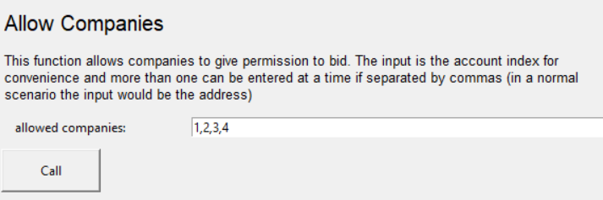
Fig. 5 Interface to allow only specific companies to bid
The bidders can only bid once for a particular tender and if any bidder tries to bid again for the tender there will be an error message forbidding the bidder to bid again. Below image shows the message shown to the bidder after a failed bid attempt.

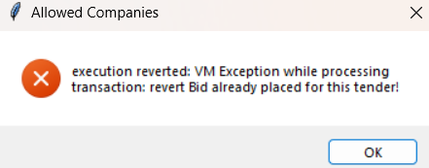
Fig. 6 Already Placed bid error

Each tender has a time period from creation to closing of the tender within which the willing bidders need to bid for the tender. Failing to bid within the specific period the bidder will not be able to bid after the closing date of the tender and the user will be prompted with an error message regarding that as shown below.

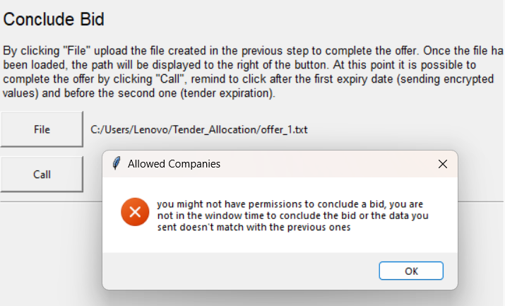
Fig. 7 Error shown if the user tries to bid after the tender deadline

There is also an option available for the bidders as well as the administrator to see all the active tenders with their details at that particular point of time. The interface showing the details of active tenders is shown below.

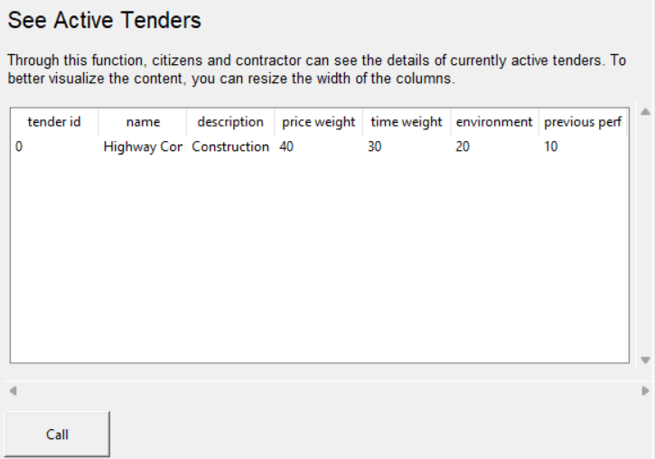
Fig. 8 Details of the active tenders

All the closed tenders can also be seen with their details such as number of participants or bidders of the tender, winner of the tender, if declared.
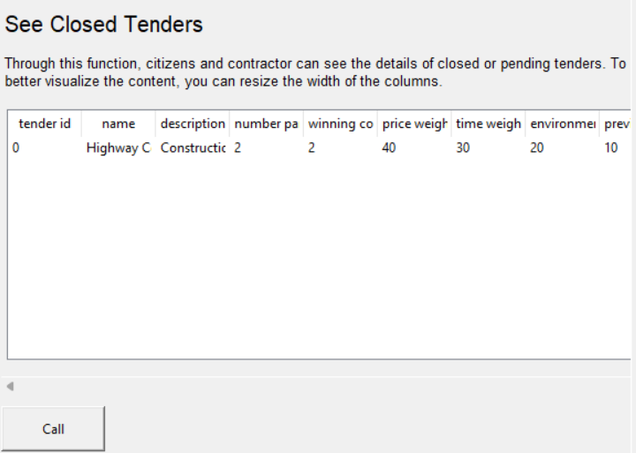
Fig. 9 Details of closed tenders along with the winner
After the tender has been closed and the winner assigned, all the users and the bidder are allowed to see the bids of all the other participants along with the bid of the winning participant which will help the bidders to know about the winner and will help them in future.
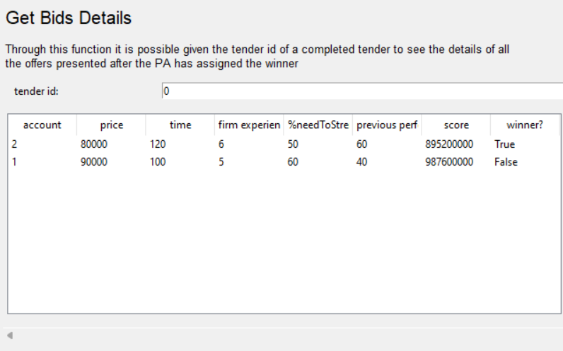
Fig. 10 Interface show bid details of all the participants

If any user or bidder tries to access the bid details of all the participants then an error message will pop up reverting the transaction.
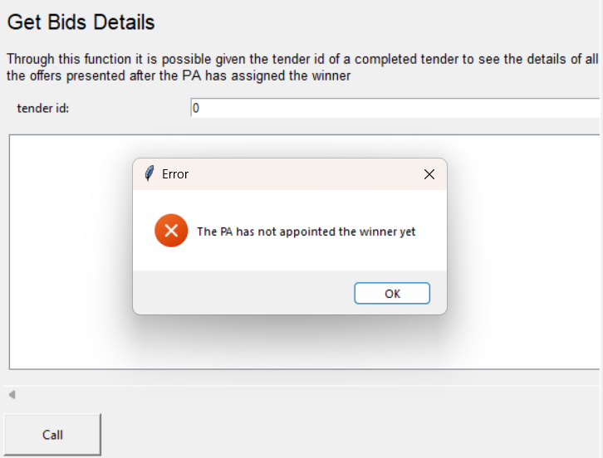
Fig. 11 Winner not appointed error message
4.4 Gas Usage Analysis
It delivers an assessment of the difficulty of various functions in the contract. It has to do with how complicated blockchain transactions are. If a transaction uses more gas than the allowed amount, the blockchain transaction is reversed. The transaction price for a function increases with the amount of gas it uses.

The graph in the image below shows how much gas was used during various blockchain transactions. The function is more difficult since the contract formation uses the most gas compared to the other functions. The product of gas usage and gas value gives us the transaction fee of the function. Typically, the gas value is taken to be 1 GWEI.

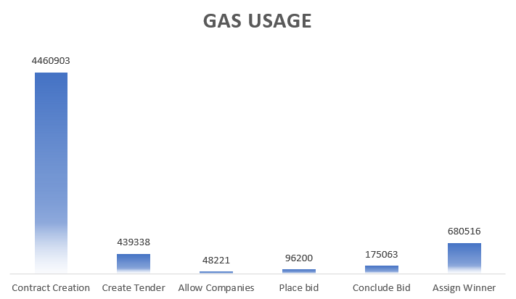
Fig. 12 Gas usage bar graph

CHAPTER 5
CONCLUSION AND FUTURE SCOPE

5.1 Conclusion
Summary of the Study
The blockchain-based secure tender allocation system study aimed to propose a secure and transparent platform for the allocation of tenders using blockchain technology. The study employed a quantitative research design, which involved the development of a conceptual framework and the use of surveys to collect data.

The findings of the study revealed that the proposed system was effective in providing a secure and transparent platform for tender allocation. The stakeholders, including the tender issuers and bidders, showed high acceptance of the system. The system was also found to be effective in reducing the likelihood of corruption, promoting transparency, and reducing the time and cost of the tender allocation process.

However, the study also identified some challenges, such as the need for the parties to have access to the internet, the lack of awareness and understanding of blockchain technology, and the possibility of cyber-attacks.

In conclusion, the study provides valuable insights into the potential of blockchain technology in providing secure and transparent platforms for tender allocation. The study recommends that further research be conducted to address the identified challenges and to explore the potential for further development and improvement of the system.

Conclusions and Recommendations
Conclusions:
The study showed that the proposed blockchain-based secure tender allocation system has the potential to address the challenges facing the traditional tender allocation process. The system was found to be effective in reducing the likelihood of corruption, promoting transparency, and reducing the time and cost of the tender allocation process. The stakeholders, including the tender issuers and bidders, showed high acceptance of the system. However, the study also identified some challenges that need to be addressed, such as the need for the parties to have access to the internet, the lack of awareness and understanding of blockchain technology, and the possibility of cyber-attacks.

Recommendations:
Based on the findings of the study, the following recommendations are made:
- Further research should be conducted to address the identified challenges and explore the potential for further development and improvement of the system.
- The stakeholders should be provided with training and education on the use of blockchain technology to enhance their understanding and acceptance of the system.
- Measures should be put in place to enhance the security of the system, including the use of advanced encryption technologies and firewalls to prevent cyber-attacks.
- The system should be integrated with smart contract technology to enable the automatic execution of terms and conditions of the tender allocation process.
- The system should be tested on a larger sample size to enhance the generalizability of the findings.
- The system should be continuously updated to keep up with the latest advancements in blockchain technology and address any emerging challenges.

In conclusion, the blockchain-based secure tender allocation system has the potential to transform the tender allocation process by providing a secure, transparent, and efficient platform. The recommendations made in this study can enhance the effectiveness and sustainability of the system, leading to improved outcomes for all stakeholders.

5.2 Limitations of the Study of blockchain
As with any research study, this study on the blockchain-based secure tender allocation system has some limitations that need to be considered when interpreting the results. These limitations include:
- Sample size: The study was conducted on a limited sample size, which may affect the generalizability of the findings to other contexts.
- Time constraints: The study was conducted within a limited time frame, which may have limited the depth and breadth of the data collected.
- Limited access to data: The study was limited by the availability and accessibility of data, which may have limited the scope and accuracy of the analysis.
- Limited access to resources: The study was conducted with limited resources, which may have affected the quality of the data collection and analysis.
- Technical limitations: The study was limited by the technical constraints of the blockchain technology, such as the potential for cyber-attacks and the need for high-speed internet connectivity.
- Lack of prior research: The study was conducted in a relatively new and evolving field, and there is limited prior research on blockchain-based secure tender allocation systems.
- Subjectivity of responses: The study relied on self-reported data, which may be subject to bias and inaccuracies.

Despite these limitations, the study provides valuable insights into the potential benefits and challenges of the blockchain-based secure tender allocation system and provides a foundation for future research in this area.

In conclusion, our project is aimed to explore the potential of blockchain technology to improve the tender allocation process. Through a review of related work and our own research, we have found that blockchain-based solutions have the potential to bring transparency, immutability, and security to the tendering process. The use of smart contracts can automate the process and reduce human errors and bias. Blockchain-based systems can track the movement of goods and services through the supply chain and improve the accountability and transparency of all parties involved in the tendering process.

However, while blockchain technology offers many advantages, there are also limitations to consider. The scalability and practicality of blockchain-based solutions must be carefully evaluated, especially in cases where a large number of participants are involved. Additionally, the use of blockchain technology requires significant investment in terms of infrastructure, development, and maintenance.

In conclusion, our project has shown that the use of blockchain technology in tender allocation has the potential to bring significant benefits, but careful evaluation and planning are required to ensure successful implementation. Future research in this area should focus on addressing the limitations of current blockchain-based solutions and exploring new ways to leverage blockchain technology to improve the tender allocation process.

Here are some additional details on the potential limitations of a study on a blockchain-based secure tender allocation system:

Limited sample size: The size of the sample used in a study can impact the reliability and generalizability of the results. If the sample size is too small, it may not accurately reflect the larger population using the system. Researchers must consider the population they want to generalize their results to when selecting a sample size. Additionally, when working with blockchain-based systems, the sample size may be limited due to the small number of organizations or users currently using the technology.

Time constraints: Blockchain-based systems are relatively new, and there may not be enough data available on the long-term performance of such systems. A study that focuses only on a short-term period may not be able to evaluate the performance of the system over an extended period. For instance, the blockchain technology is still evolving, and it is essential to study how the technology can adapt to the changing needs of the users.

Data accuracy: The accuracy and completeness of the data collected during a study can impact the validity of the results. Inaccurate data can result in incorrect conclusions being drawn from the analysis. The researchers must ensure that the data collected is accurate and reliable, and they must take steps to prevent data errors and biases.

Bias: The presence of bias in a study can impact the validity and reliability of the results. Researchers must ensure that the data collection and analysis process is as objective as possible. For example, if the researchers only select participants who are favorable to the use of blockchain-based systems, the results may be biased in favor of the technology.

Security concerns: Blockchain-based systems often involve sensitive data, such as personal and financial information. When conducting a study on a blockchain-based secure tender allocation system, researchers must ensure that the data collected is kept secure and that the study does not violate any privacy regulations.

Limited availability of previous research: Since blockchain-based systems are relatively new, there may be limited previous research on the topic. As a result, it may be challenging to compare the results of the study with other similar studies. This limitation can affect the generalizability of the study's findings.

It is crucial for researchers to consider and acknowledge these limitations when conducting a study on a blockchain-based secure tender allocation system. They must take steps to minimise the impact of these limitations and ensure that the results are as reliable and accurate as possible.

5.3 Future Scope
Future Research Directions
The blockchain-based secure tender allocation system is a relatively new and rapidly evolving field that has the potential for significant impact on the procurement process. Future research directions for this system include:
- Further investigation of the technical aspects of blockchain technology, such as scalability, interoperability, and security.
- Exploration of the potential economic benefits of using blockchain-based secure tender allocation systems, including cost savings, increased efficiency, and reduced fraud.
- Investigation of the potential social and ethical implications of blockchain-based secure tender allocation systems, including privacy concerns and the impact on traditional procurement practices.
- Evaluation of the effectiveness of blockchain-based secure tender allocation systems in different contexts and industries, including government, healthcare, and education.
- Development of new models and frameworks for the integration of blockchain technology into the procurement process.
- Investigation of the potential for blockchain-based secure tender allocation systems to improve transparency and accountability in the procurement process.
- Research on the adoption and implementation of blockchain-based secure tender allocation systems, including the challenges and barriers to adoption.

Overall, future research in the area of blockchain-based secure tender allocation systems will be critical in advancing our understanding of this technology and its potential for improving the procurement process.

In the future, we can simplify the system and make it more efficient so that it uses less gas price value, making it more efficient and affordable to all users. Currently, it takes some small amount of gas price to view the result to the non-bidding user, in future we can try to make some further changes so that it uses least or no amount of gas price for normal operations.

REFERENCES
- Fair and Transparent Blockchain based Tendering Framework - Freya Sheer Hardwick, Raja Naeem Akram, and Konstantinos Markantonakis ISG-SCC, Royal Holloway, University of London, Egham, United Kingdom
- Blockchain-based e-Tendering System - Proceedings of the International Conference on Intelligent Computing and Control Systems (ICICCS 2020) IEEE Xplore Part Number:CFP20K74-ART; ISBN: 978-1-7281-4876-2
- Zibin zheng, Shaoan Xie, Hongning Dai, Xiangping Chen, Huaimin Wang “An Overview of Blockchain Technology: Architecture, Consensus, and Future Trends”, 2017 IEEE International Congress on Big Data (BigData Congress), IEEE, 2017
- Vikas Hassija , Vinay Chamola, Mohsen Guizani, Neeraj Kumar “A Blockchain and Edge-Computing-Based Secure Framework for Government Tender Allocation” IEEE Internet of Things Journal PP(99)
- Ambegaonker, Ajeenkkya, Utkarsh Gautam, and Radha Krishna Rambola. "Efficient approach for Tendering by introducing Blockchain to maintain Security and Reliability." 2018 4th International Conference on Computing Communication and Automation (ICCCA). IEEE, 2018.
- Tender Allocation Using Blockchain Technology - International Journal of Creative Research Thoughts (IJCRT) www.ijcrt.o
- Vikas Hassija , Vinay Chamola, Mohsen Guizani, Neeraj Kumar “A Blockchain and Edge-Computing-Based Secure Framework for Government Tender Allocation” IEEE Internet of Things Journal PP(99)
- Charles E Darwin1 , Avinash Kothandan2 , Athmanathan M3 , Shanthi S 4 “Tender Allocation using Blockchain Technology” 2022 IJCRT, Volume 10, Issue 5 May 2022.
- Thilak K, Prof. Priya N “Smart Tender/Contract Management System Using Blockchain”, International Research Journal of Modernization in Engineering Technology and Science, Volume 04, Issue 04, April 2022
- De Xu and Qing Yang “The Systems Approach and Design Path of Electronic Bidding Systems Based on Blockchain Technology” MDPI, Electronics 2022, 11, 3501
- H. Hou, “The Application of Blockchain Technology in E-government in China”, in 2017 26th International Conference on Computer Communication and Networks (ICCCN). IEEE, 2017, pp. 1-4.
- Svein Ølnes and Arild Jansen “Blockchain Technology as s Support Infrastructure in e-Government” International Conference on Electronic Government, Springer, 2017, pp 215-227
- Yiwei Zhang, Sanhong Deng, Yue Zhang, Jia Kong “Research on Government Information Sharing Model Using Blockchain Technology”, 2019 10th International Conference on Information Technology in Medicine and Education (ITME), IEEE, 2019
- S. Rama, S. V. Flowerday, and D. Boucher, “Information Confidentiality and the Chinese Wall Model in Government Tender Fraud”, in 2012 Information Security for South Africa. IEEE, 2012, pp. 1-8.
- Bellare, Mihir; and Rogaway, Phillip. (September 21, 2005). “Introduction.” In Introduction to Modern Cryptography (p. 10).

APPENDIX 1
Secure E-Tender Allocation Using Blockchain
Vipul Kumar^{1, a)}, Vishwaas Saxena^{2, b)}, Shivangi Pandey^{3, c)} and Neha Yadav^{4, d)}
^{1,2,3,4} Department of Computer Science and Engineering, KIET Group of Institutions, Ghaziabad, Uttar Pradesh, India

^{a)} Corresponding author: vipulmy10@gmail.com
^{b)} vishwaas7saxena@gmail.com
^{c)} shivangipandey.r@gmail.com
^{d)} nehayadav1508@gmail.com
Abstract. Organizations in the public sector's permissionless blockchain, including those in the government, are working to discover new means to stay in operation. Along with technological progress, cost reductions, wise governance, and work efficiency. Blockchain technology is one such innovation that has recently attracted the attention of governments all around the world. The blockchain's increased security, enhanced traceability, and lowest-cost infrastructure allow it to penetrate numerous industries. Governments frequently issue tenders to a small number of outside companies for a variety of projects. Many competitors attempt to overhear out the tender values of their rivals to win the contract. Furthermore, dishonest government representatives seek a sizable bribe in exchange for passing the offer to a third party. In this work, we present a blockchain-based architecture for public procurements that are both secure and efficient.
Keywords: Blockchain, Ethereum, Smart Contracts, Decentralized system, Tender Allocation

INTRODUCTION
Nearly all industries and regions of the world have seen a significant increase in the usage and acceptance of blockchain technology. To improve the level of safety, confidentiality, transparency, and work efficiency, government tender processes can make use of up-and-coming blockchain technology [16]. Blockchain technology can make it possible for all parties interested in a given offer to be a part of the same network and to track the workflow in real time. Governments in countries like Georgia, the UK, the UAE, Australia, China, Japan, and Russia are integrating blockchain technology into their daily operations at a rapid rate nowadays [4][7]. In recent years, the governments of several developing nations, including India, are coming up with initiatives and regulations for the adoption of blockchain technology.
In practically all industries and regions of the world, the usage of blockchain technology has grown quickly. To increase the level of secure allocations, privacy, openness, and productivity throughout the government tender process, blockchain technology is a very promising alternative [11]. Blockchain technology enables all parties engaged in a tender to join a particular network and helps in real-time transaction monitoring of the network [1].
In other terms, blockchain is a digital ledger for transactions or contracts that need to be recorded. It is a secured, distributed database that stores data [16][10]. In practically all industries and regions of the world, the usage of blockchain technology has increased more quickly. Online reservation systems, modes of digital acquisition, and the submission of tax returns, and other things, are only a few examples of the numerous initiatives undertaken to apply innovations to develop paperless and quick government procedures. Despite these systems being well-designed and implemented, all of them are based on the idea that a host could fail because attackers could easily hack or prevent it from functioning using attacks like DOS attacks, and Man in the Middle attack, among others [17]. In most nations, complex regulatory requirements result in faulty workflows that are plagued with corruption, inefficiency, and human neglect. Several governance processes, including government tenders, involve data leakage, dishonesty, and bribery [5]. By tackling these problems, we hope to create a transparent and more safe fog computing infrastructure for the distribution of contracts that besides doing away with the need and tendency for in-person oversight or intervention; makes it simple for the administration to monitor and revise its rules and policies over time. We suggest a formation to use blockchain technology to build a dispersed system to perform and look over government and its tendering processes easily, transparently, and immutably to address this problem [11].

Background
Blockchain architecture is a shared database or public ledger of records or transactions used by many parties in a network. A blockchain network can be joined by a participant freely based on whether it is Permission-less (Public) or Permissioned (Private) [11]. Any user of a permissionless blockchain network, such as Bitcoin, is given a special address through which they can communicate with the network, enabling anyone to take part in the transaction validating process [1][10]. A closed environment known as a permissioned blockchain prohibits users from freely joining the network matrix, viewing the recorded ledger, or issuing exchanges [14]. The fact that a Permissionless Blockchain requires a lot of computational power to reach consensus and that the transaction history is publicly available is one of the main disadvantages that prevent the majority of businesses from utilizing it [13]. The participation of the general public is restricted by the permissioned blockchain, which places restrictions on the parties who can transact on the blockchain. As a result, we employ consortium blockchain, which takes advantage of both networks' strengths. While the transactions are only validated by the authorities and co-authors, common constructors or construction firms are permitted to join the network by adding their legitimate IDs [10]. Thus, a consortium blockchain offers an additional layer of privacy while nevertheless having all the key benefits of a permissionless network. Ethereum is one such platform that enables the development of distributed applications [10][17]. It is a cross-industry open-source collaborative project designed to improve blockchain technologies [3]. It enables the establishment of specific Confidential Channels that can maintain a distinct ledger that is only accessible to those who participate in that channel. Government offices can be divided into multiple departments, each of which has its own set of authorities that can view and verify transactions only related to that department [13].

Related Work
There are several studies and examples of projects that have been made using blockchain technology for tender allocation. One notable project is the "Smart Tenders" platform developed by the European Union's Horizon 2020 research program. This uses blockchain technology to automate the evaluation of bids. This platform also allows users to build a reputation over time, which is used as an assessment parameter while providing contracts. Another example is the "Blockchain-based Public Procurement Platform" which is developed by the government of the Republic of Korea. This platform aims to increase transparency and reduce the risk of fraud in the public procurement process [16]. The platform uses blockchain technology to record all activities and allows all participants to access the same information. The "Blockchain-based e-Procurement System" which is developed by the government of Andhra Pradesh, India is also a recent example of the same. The system aims to automate the allocation process using blockchain technology to ensure the transparency and security of the process. The system also allows for the tracking of goods and services. In addition to these specific projects, there have also been several academic studies that have looked at the use of blockchain in tender allocation.
Overall, related work on blockchain-based tender allocation projects has shown that the technology has the potential to bring transparency, immutability, and security to the tendering process, along with automation and reduction in human errors.

Proposed Work
Government lenders and builders first join the blockchain architecture to build a safe fog computing infrastructure. All relevant constructors are informed about the tender information by the government lender. The suggested concept is a decentralized and consortium architecture that blends the permissioned blockchain's security and privacy with the permissionless blockchain's openness and transparency. The concept aims to manage the government tender process securely and effectively. Government authorities, outside parties like construction corporations or individual contractors, and banks make up the system's core three sorts of entities. Based on identity identification, we can use Ethereum to restrict the network nodes' access to data [2][3]. The files are only accessible to the nodes that are authorized to examine or validate the specific data [13].
This system extensively uses smart contracts in its functioning to deploy the tender and the rest of the functioning which extends to score formulation and assignment of tenders to the winning party. Smart Contracts are contracts that may be enforced by the law and are written using standardized code and operational specifications [10][14]. Until and unless all the nodes of the network verify and flag the transaction as legitimate it cannot be added to the block. The final exchange history and the blockchain will both contain the transaction details when they have been confirmed, together with a timestamp and the parties' public keys [11]. A collection of key-value pairs are created as a result of the execution of smart contracts and are recorded and maintained on the ledger and preserved on the blockchain [7].
The implementation of the project is divided into these categories:

Creation of Tenders
Tender is created by the government for interested parties to bid and to be allotted to the potential party who is the most suitable according to the proposed parameters. Each tender has a unique name and id (tender key) and a description containing the nature of the tender and its requirements. The tender key keeps the record of the number of tenders created so far. Tenders have certain parameters that set the characteristics of the tender. Every tender has a fixed date stamp until which the interested parties can bid and accordingly, the bidding hash can be created.

Bid Parameters
These parameters are the set of characteristics or requirements that are specified for a tender, which is a formal invitation to submit a proposal for a project or supply of goods or services.

Time
The time parameter refers to the duration of the tender process, which is typically divided into two periods - the time between the opening and closing of the tender, during which parties can submit their bids, and the time for evaluating the bids and selecting a winner. The time parameter may also include specific deadlines for submitting bids, as well as any deadlines for clarifying or modifying the bid.

Price
The price parameter specifies the maximum or minimum price that can be offered in a bid. This can be a fixed price or a range of prices, and it may be based on a variety of factors such as the cost of materials, labor, and overhead. The price parameter may also specify any discounts or rebates that can be offered as part of the bid.

Environment
The environment parameter refers to the physical, social, or economic conditions in which the project or goods will be delivered. This could include factors such as the location of the project, the type of industry or market, and any relevant regulations or standards that must be met. The environment parameter may also specify any specific challenges or constraints that the bidder must consider when preparing their proposal.

Also, if any unauthorized organization tries to create a tender by invoking create tender function, then it will receive an error representing transaction failure. The below image shows the failed transaction.
FIGURE 1. No permission to Create Tender

FIGURE 2. Create Tender
FIGURE 3. Create Tender Output

Place Bid
The function placeBid is used to place a bid for a tender identified by the tenderKey argument. It takes in three arguments: tenderKey, firmAddress, and hashOffer. The bid is placed by a firm identified by the firmAddress argument, and the hashOffer argument provides a hash of the offer made by the firm. The function begins by retrieving the tender identified by the tenderKey argument from the tenders mapping and storing it in a variable named tender. Next, the function sets the AlreadyBid field of the tender to true for the firm identified by the firmAddress argument. This indicates that the firm has already placed a bid for this tender and cannot participate in the tender anymore [1][8].
Finally, the function creates a new BidOffer object for the tender and assigns it to the bids field of the tender for the firm identified by the firmAddress argument. The BidOffer object is initialized with the following values:
Firm Address: the firm placing the bid
Hash Offer: the hash value of the offer.
FIGURE 4. Place Bid

Concluding Bid
The function for concluding whether a bid is valid or not is named concludeBid and it takes in four arguments: tenderKey, firmAddress, bidValues, and separator. The function is used to conclude a bid for a tender identified by the tenderKey argument. The bid is placed by a firm identified by the firmAddress argument. The values of the bid are provided in the bidValues argument, and the separator argument indicates the separator that arises between these values. The function begins by retrieving the tender identified by the tenderKey argument from the tenders mapping and storing it in a local variable named tender.
Next, the function sets the values field of the bid placed by the firm identified by the firmAddress argument to the bidValues argument. The separator field of the bid is also set to the separator argument. Finally, the valid field of the bid is set to true to indicate that the bid is now considered valid.

Score Formulation Parameters
Previously, we were using three main parameters - time, price, and the environment - to determine the result of a bid. Now, we are dividing the environment parameter into subcategories to calculate the score for the environment variable. The environment parameter is used to evaluate the impact that a bidder's work will have on the environment. Dividing it into subcategories allows for a more detailed evaluation of this impact. Also, it becomes easier to accurately assess the environmental impact of a bidder's work. These subcategories include the firm's experience and the percentage of matching between the contract requirements and the company's strengths. In addition to these three parameters, a fourth parameter - the firm's deliverance rate - is being introduced. These four parameters will be used to formulate the original score of the bidder, which will be used to calculate the result.
The subcategories of the environment parameter will have fixed weights that will be used to calculate its score. Once the environment score has been determined, variable weights will be applied according to the needs of the tender to calculate the overall score, which will be used to determine the winner. Once the scores for each of the subcategories have been calculated, they can be combined to formulate the overall score for the environment parameter. This score can then be used along with the scores for the time and price parameters to determine the final result of the bid.

Assign the Winner
After the scores are formulated for each of the bidders, all of these scores are saved along with the data of the bidder. To assign the final winner of the bidding process, an iterator iterates through all the participants of the bidding process and checks for the maximum formulated score present in the data structure, as the maximum score is known after the completion of the iteration, and the winner is assigned.

Results and Analysis
The results of the simulation showed that the blockchain-based system was able to provide a tamper-proof record of the tender process, increasing transparency and reducing the potential for fraud. Additionally, the system was found to improve efficiency by automating the process through the use of smart contracts. The smart contracts were able to ensure that all the terms of the contract were met and that the process was completed quickly.
With the help of blockchain, we have come up with a transparent and safe e-tender allocation system for efficient tender allocation while maintaining the security of contracts and the privacy of the bidders. In our implementation, we have used a Python interface based on tkinter to communicate with the contracts. Using which we can easily view the details of the tender, analyze and view the bidding details of the winner and the participants once the winner has been declared. Using this interface all the other participants can view the details of all other bidders and gain experience as to bring about changes in their future bids. If in any case any participant tries to access the details of other bids, an error will be displayed, and the data will not be accessible before the final results of the tender are out. This provides complete secrecy and prevents any breach of data leading to the cause of unfair decisions.
FIGURE 5. Gas Usage Bar Graph

Gas Usage Analysis
It gives an estimate of the complexity of various functions in the contract. It is related to the complexity of blockchain transactions. The blockchain transaction gets reverted if the transaction uses more gas than the specified gas limit. The higher the gas usage of a function, the higher will be its transaction fee.
The figure above is a bar graph depicting the gas usage of different transactions of the blockchain. The contract creation has the highest gas usage when compared with others which accounts for the complexity of the function. The product of gas usage and gas value gives us the transaction fee of the function. Generally, the gas value is taken to be 1 GWEI.

Conclusion
This paper is explained in the context to impress blockchain technology as a means to create a tender allocation system. We have discussed significant opportunities that the technology offers while focusing on transparency. The algorithms are traceable and secure ensuring the bidding process is genuine. Ethereum has been used as a means to connect edge-to-edge frameworks [10]. Mechanisms are designed in a way to yield maximum profits to the government and the lenders. In comparison to the other models, the suggested one yields better results and is interactive. We are upon aim to develop and cater to broader needs.

Future Scope
Our work regarding this technology is to incorporate all the literary sources and surveys on the importance and conjecture of blockchain technology along with web security. We aim to project meaningful data to the users along with upvoted factors. We are trying to unveil the current trends of this technology and further ignite future research. The trends in this area of blockchain have been accelerating for the past five years. We are trying to answer numerous questions with our approach:

What changes did our model bring in the course of this project?
Why pursuing our model is better?
Why are the challenges in the future aspect of Blockchain in this domain?

References
- V. Hassija, V. Chamola, D. N. Gopala Krishna, N. Kumar and M. Guizani, “A Blockchain and Edge-Computing-Based Secure Framework for Government Tender Allocation,” IEEE Internet of Things Journal 8, 2409-2418 (2021).
- A. Ambegaonker, U. Gautam and R. K. Rambola, “Efficient approach for Tendering by introducing Blockchain to maintain Security and Reliability,” in 2018 4th International Conference on Computing Communication and Automation (ICCCA) (Greater Noida, India, 2018), pp. 1-4.
- Charles E Darwin1, Avinash Kothandan2, Athmanathan M3, Shanthi S 4, “Tender Allocation using Blockchain Technology” in 2022 International Journal of Creative Research Thoughts (IJCRT) 10, (2022).
- Mihir Bellare and Phillip Rogaway, Introduction to Modern Cryptography, (Davis, University of California, 2005), p. 10.
- Betts, Martin & Black, Peter & Christensen, Sharon & Dawson, Ed & Du, Rong & Duncan, William & Foo, Ernest & Nieto, Juan, “Towards secure and legal E-tendering,” Journal of Information Technology in Construction 11, 89-102 (2006).
- Ravina More, Pratiksha Kadam, Tejal Phadtare, Ketaki Bhagat, Prof. C.S. Wagh, “Secure Framework for Government Tender Allocation using Blockchain”, International Journal of Advanced Research in Science, Communication and Technology (IJARSCT) 2, (2022).
- Dr. W. Gracy Theresa, Kishore.G, Kishan Kumar V, Mohamed Shafiq J, “A Blockchain and Edge Computing-based Secure Framework for Government Tender Allocation,” International Journal of Innovative Research in Science, Engineering and Technology (IJIRSET) 10, (2021).
- D. Mali, D. Mogaveera, P. Kitawat and M. Jawwad, “Blockchain-based e-Tendering System,” in 2020 4th International Conference on Intelligent Computing and Control Systems (ICICCS) (Madurai, India, 2020), pp. 357-362.
- Li Li, Jiayong Liua, Peng Jia SecTEP “Enabling secure tender evaluation with sealed prices and quality evaluation in procurement bidding systems over the blockchain”, Computers & Security 103, 102188 (2021).
- Svein Ølnes and Arild Jansen “Blockchain Technology as s Support Infrastructure in e-Government,” in International Conference on Electronic Government, (Springer, 2017), pp. 215-227.
- Y. Zhang, S. Deng, Y. Zhang and J. Kong, “Research on Government Information Sharing Model Using Blockchain Technology,” in 2019 10th International Conference on Information Technology in Medicine and Education (ITME, 2019) (Qingdao, China, 2019), pp. 726-729.
- S. Rama, S. V. Flowerday, and D. Boucher, “Information Confidentiality and the Chinese Wall Model in Government Tender Fraud,” in 2012 Information Security for South Africa (IEEE, 2012), pp. 1-8.
- H. Hou, “The Application of Blockchain Technology in E-government in China”, in 2017 26th International Conference on Computer Communication and Networks (ICCCN) (IEEE, 2017), pp. 1-4.
- Z. Zheng, S. Xie, H. Dai, X. Chen and H. Wang, "An Overview of Blockchain Technology: Architecture, Consensus, and Future Trends," in 2017 IEEE International Congress on Big Data (BigData Congress) (Honolulu, HI, USA, 2017), pp. 557-564.
- Min Xu, Xingtong Chen and Gang Kou “A systematic review of blockchain”, Financial Innovation 5, 27 (2019).
- D. Xu and Q. Yang, “The Systems Approach and Design Path of Electronic Bidding Systems Based on Blockchain Technology,” Electronics 11, 3501, (2022).
- Thilak K, Prof. Priya N “Smart Tender/Contract Management System Using Blockchain”, International Research Journal of Modernization in Engineering Technology and Science 4, (2022).

